“survey” columns:

* question
* user_id
* response

SELECT question,

COUNT(DISTINCT user_id)

FROM survey

GROUP BY 1;

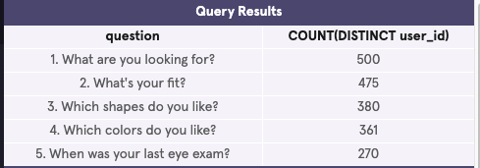

“quiz” columns:

* user_id
* style
* fit
* shape
* color

“home_try_on” columns:

* user_id
* number_of_pairs
* address

“purchase” columns:

* user_id
* product_id
* style
* model_name
* color
* price

SELECT DISTINCT q.user_id,

h.user_id IS NOT NULL AS 'is_home_try_on',

h.number_of_pairs,

p.user_id IS NOT NULL AS 'is_purchase'

FROM quiz q

LEFT JOIN home_try_on h

ON q.user_id = h.user_id

LEFT JOIN purchase p

ON h.user_id = p.user_id

LIMIT 10;

